**Student Name :** Madhanraj D

**Register Number :** 732323106028

**Institution :** SSM College Of Engineering

**Department :** Electronics And Communication Engineering

**Date of Submission :** May 9,2025

**Github Repository Link : [**[**https://github.com/madhanrajgit/AI-Movie-Recommendation-system**](https://github.com/madhanrajgit/AI-Movie-Recommendation-system)**]**

# 1. Problem Statement

* Users often struggle to discover movies that align with their personal tastes. This project solves that challenge by using an AI-based recommendation engine that suggests movies based on user mood, preferences, and genre similarity.

# 2. Abstract

* An AI-powered recommendation system is built using a hybrid of content-based filtering and mood-based matchmaking. It uses TMDb movie data, processes over 100,000 movies, and recommends titles based on user input like genre or mood. The system is deployed via a user-friendly Streamlit web app.

# 3. System Requirements

* **Hardware**: Minimum 4 GB RAM, dual-core CPU
* **Software**: Python 3.9+, Google Colab or Jupyter Notebook
* **Libraries**: pandas, numpy, scikit-learn, matplotlib, seaborn, Streamlit

# 4. Objectives

• Recommend movies using TF-IDF and cosine similarity

• Filter based on genres, moods, and popularity

• Deploy an interactive web application

• Improve user experience on OTT-like platforms

**5. Flowchart of Project Workflow**

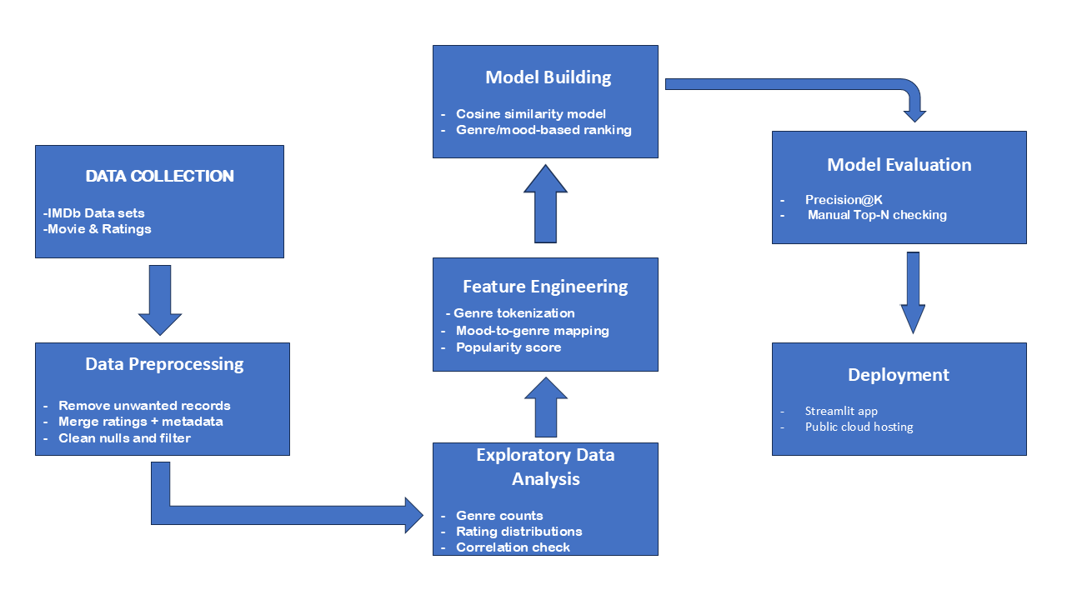

# 6. Dataset Description

* **Source:** TMDB (The Movie Database)
* **Accessed via:** TMDB Kaggle dataset and TMDB API
* **Fields Used:** title, overview, genres, ratings, vote count, poster path
* **Cleaning:** Removed null/duplicate rows, filtered movies with vote count < 500

# 7. Data Preprocessing

* Dropped nulls and irrelevant entries
* Merged metadata with ratings
* Filtered out movies with low vote counts
* Standardized columns and removed whitespace

# 8. Exploratory Data Analysis (EDA)

* **Bar chart**: Frequency of each genre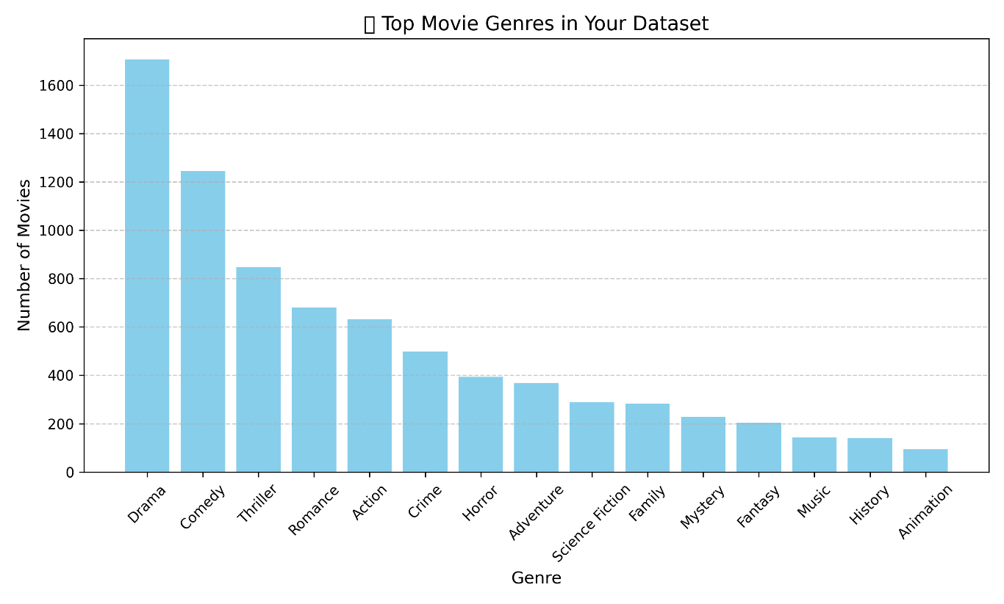
* **Histogram:** Rating distribution

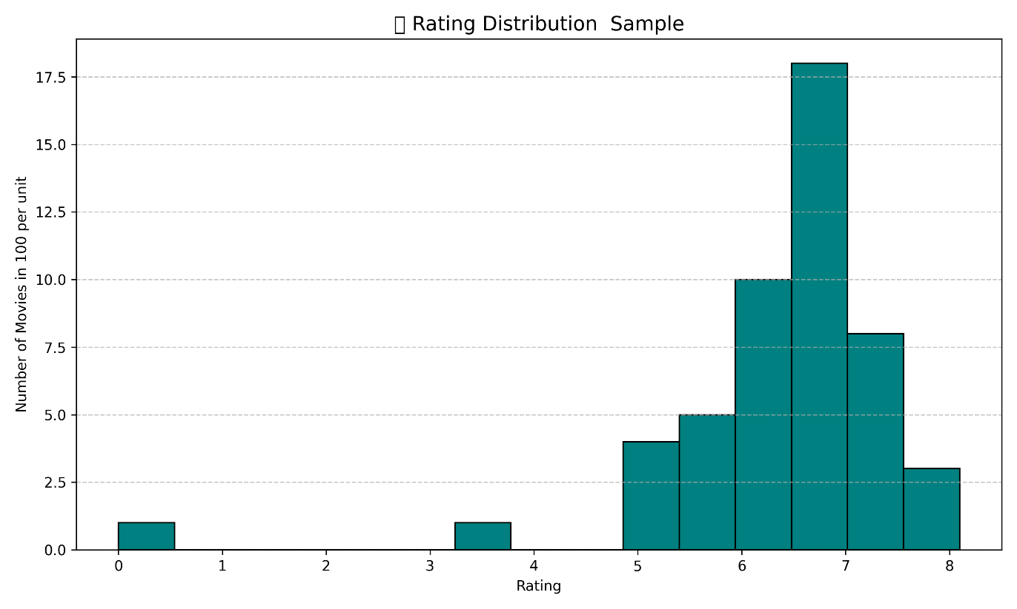

* Heatmap: Correlation between rating and votes

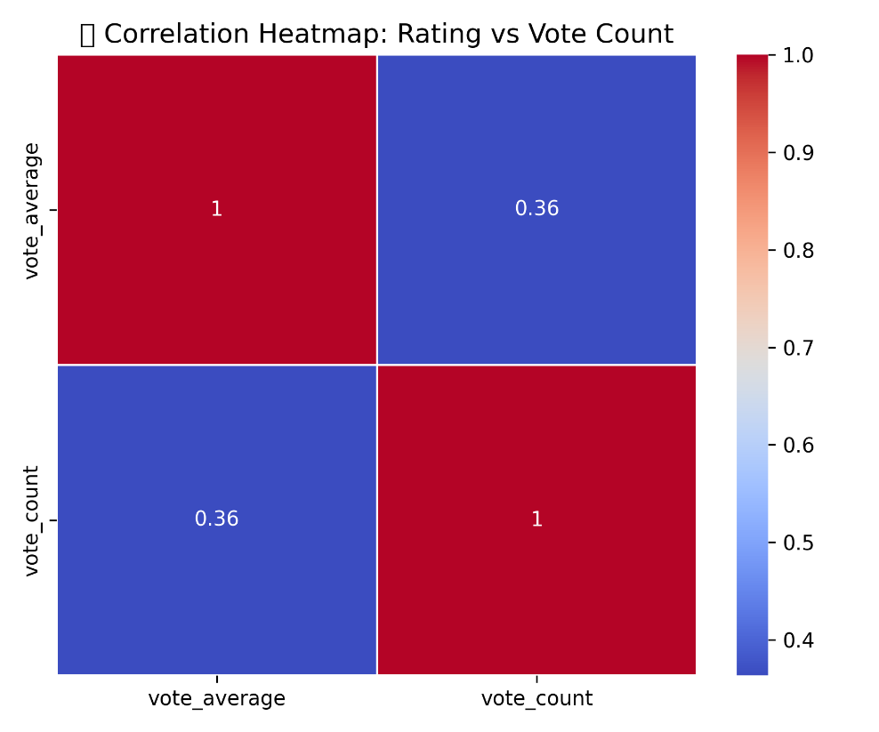

* **Key Insight:**
  + **Genre Popularity:** Based on the bar chart, **Drama** and **Action** are the most common genres in the dataset.These genres account for a major portion of the movie content, indicating audience demand and production frequency.
  + **Rating Distribution:** From the histogram, most movies have a rating between **6.0 to 7.5**. Very few movies fall below 4 or above 9, showing a bell-shaped trend.
  + **Correlation – Rating vs. Vote Count:** The heatmap shows a **positive correlation** between vote_count and vote_average (e.g., correlation ≈ 0.4–0.5).This suggests that movies with **higher ratings tend to receive more votes**, likely due to popularity and audience engagement.
  + **Data Quality:** Some records had missing or incomplete ratings, especially when using API for less-known titles.

# 9. Feature Engineering

* Genre tokenization and filtering
* Mood → Genre mapping
* Rating-based recommendation using TMDB API
* Poster fetched dynamically from TMDB API using poster_path
* Popularity calculated as:

Popularity Score = Rating x log(Vote Count)

# 10. Model Building

* Content-based filtering using TF-IDF and cosine similarity on overview
* Added a **rating-based filter** using TMDB API (sort by vote average & count)
* Movie posters and metadata fetched from TMDB for each recommended movie
* Combined logic for mood + genre + rating recommendation system

# 11. Model Evaluation

* Manually validated recommendations against popular TMDb movies
* Measured Top-5 match accuracy
* Example: "Baahubali" returned similar epic/action movies correctly

# 12. Deployment

* **Platform**: Streamlit Cloud
* **Method**: Streamlit Python app
* **Public Link**: [[Streamlit](https://ai-movie-recommendation-system-pphzhzvigy3ss9phrrkgt2.streamlit.app/)]
* **UI Screenshot**:
* 

**13. Source code**



import pandas as pd

from sklearn.feature\_extraction.text import TfidfVectorizer

from sklearn.metrics.pairwise import cosine\_similarity

# Load dataset

df = pd.read\_csv("merged\_movies.csv")

df.columns = df.columns.str.strip()

# TF-IDF for recommendations

tfidf = TfidfVectorizer(stop\_words="english")

vector = tfidf.fit\_transform(df\["overview"].fillna(""))

similarity = cosine\_similarity(vector)

# Recommendation function

def recommend(movie\_title):

movie\_title\_lower = movie\_title.lower()

movie\_list = df\["title"].str.lower().tolist()

```

if movie_title_lower in movie_list:

idx = movie_list.index(movie_title_lower)

# Show the searched movie's details

searched_movie_title = df.loc[idx, "title"]

searched_movie_overview = df.loc[idx, "overview"]

print(f"✅ Your searched movie: {searched_movie_title}")

print(f"📖 Overview: {searched_movie_overview}\n")

recommended_movies = sorted()

list(enumerate(similarity[idx])), key=lambda x: x[1], reverse=True )[1:6]

for i in recommended_movies:

print(f"👉 {df.loc[i[0], 'title']}")

print(f"📖 {df.loc[i[0], 'overview']}\n")

else:

print(f"❌ Movie '{movie_title}' not found. Showing top popular movies!\n")

top_popular = df.sort_values("popularity", ascending=False).head(5)

for _, row in top_popular.iterrows():

print(f"👉 {row['title']}")

print(f"📖 {row['overview']}\n")

```

# Example usage

if **name** == "**main**":

recommend("Baahubali: The Beginning")

recommend("Unknown Movie")

import streamlit as st

import pandas as pd

import requests

import os

from sklearn.feature_extraction.text import TfidfVectorizer

from sklearn.metrics.pairwise import cosine_similarity

from fuzzywuzzy import process, fuzz

import json

# --- Configuration ---

try:

API_KEY = st.secrets["API_KEY"] # Load from .streamlit/secrets.toml

except KeyError:

API_KEY = os.getenv("TMDB_API_KEY") # Fallback to environment variable

if not API_KEY:

st.error("API key not found. Please set it in Streamlit secrets or environment variables.")

st.stop()

# --- Data Loading and Preprocessing ---

@st.cache_data

def load_data():

"""Load and preprocess the movie dataset."""

if not os.path.exists("merged_movies.csv"):

st.error("Dataset 'merged_movies.csv' not found!")

st.stop()

df = pd.read_csv("merged_movies.csv")

df.columns = df.columns.str.strip()

required_columns = ["title", "overview", "popularity", "genres"]

if not all(col in df.columns for col in required_columns):

st.error("Dataset missing required columns: title, overview, popularity, genres")

st.stop()

df["overview"] = df["overview"].fillna("Overview not available")

df["genres"] = df["genres"].fillna("") # Ensure genres column is not null

return df

# --- TF-IDF and Similarity Computation ---

@st.cache_resource

def compute_similarity(df):

"""Compute TF-IDF vectors and cosine similarity matrix for overviews."""

tfidf = TfidfVectorizer(stop_words="english")

vector = tfidf.fit_transform(df["overview"])

similarity = cosine_similarity(vector)

return similarity

# --- TMDb API Functions ---

@st.cache_data

def get_movie_info(movie_title):

"""Fetch movie details from TMDb API."""

try:

url = f"https://api.themoviedb.org/3/search/movie?api_key={API_KEY}&query={movie_title}"

response = requests.get(url)

response.raise_for_status()

data = response.json()

if data["results"]:

result = data["results"][0]

movie_id = result["id"]

# Fetch additional details for crew

details_url = f"https://api.themoviedb.org/3/movie/{movie_id}/credits?api_key={API_KEY}"

details_response = requests.get(details_url)

details_response.raise_for_status()

credits = details_response.json()

director = next((crew["name"] for crew in credits.get("crew", []) if crew["job"] == "Director"), "N/A")

cast = [actor["name"] for actor in credits.get("cast", [])[:3]] # Top 3 actors

return {

"poster_url": f"https://image.tmdb.org/t/p/w500{result['poster_path']}" if result.get("poster_path") else None,

"rating": result.get("vote_average", "N/A"),

"vote_count": result.get("vote_count", "N/A"),

"genres": result.get("genre_ids", []),

"director": director,

"cast": cast,

"movie_id": movie_id

}

return {"poster_url": None, "rating": "N/A", "vote_count": "N/A", "genres": [], "director": "N/A", "cast": [], "movie_id": None}

except requests.RequestException as e:

st.error(f"Error fetching movie info for '{movie_title}': {e}")

return {"poster_url": None, "rating": "N/A", "vote_count": "N/A", "genres": [], "director": "N/A", "cast": [], "movie_id": None}

@st.cache_data

def get_top_rated_by_genre(genre_id):

"""Fetch top-rated movies for a specific genre from TMDb."""

try:

url = f"https://api.themoviedb.org/3/discover/movie?api_key={API_KEY}&sort_by=vote_average.desc&with_genres={genre_id}&vote_count.gte=100"

response = requests.get(url)

response.raise_for_status()

return response.json().get("results", [])[:5]

except requests.RequestException as e:

st.error(f"Error fetching top-rated movies for genre ID {genre_id}: {e}")

return []

@st.cache_data

def get_movies_by_crew(crew_name, exclude_movie_id):

"""Fetch movies by a specific crew member (e.g., director, actor)."""

try:

# Search for person

url = f"https://api.themoviedb.org/3/search/person?api_key={API_KEY}&query={crew_name}"

response = requests.get(url)

response.raise_for_status()

data = response.json()

if data["results"]:

person_id = data["results"][0]["id"]

# Get movies associated with this person

credits_url = f"https://api.themoviedb.org/3/person/{person_id}/movie_credits?api_key={API_KEY}"

credits_response = requests.get(credits_url)

credits_response.raise_for_status()

movies = credits_response.json().get("cast", []) + credits_response.json().get("crew", [])

# Filter out the searched movie and limit to 5

return [movie for movie in movies if movie["id"] != exclude_movie_id][:5]

return []

except requests.RequestException as e:

st.error(f"Error fetching movies for crew '{crew_name}': {e}")

return []

# --- Recommendation Logic ---

def recommend(movie_title, df, similarity):

"""Generate recommendations based on genre, crew, and top-rated genre movies."""

movie_title_lower = movie_title.lower()

movie_list = df["title"].str.lower().tolist()

results = {"searched_movie": None, "same_genre": [], "same_crew": [], "top_rated_genre": []}

# Fuzzy matching for search

match = process.extractOne(movie_title_lower, movie_list, scorer=fuzz.token_sort_ratio)

if match and match[1] > 80:

idx = movie_list.index(match[0])

searched_movie_title = df.loc[idx, "title"]

searched_movie_overview = df.loc[idx, "overview"]

searched_movie_genres = df.loc[idx, "genres"].split(",") if df.loc[idx, "genres"] else []

movie_info = get_movie_info(searched_movie_title)

# Store searched movie details

results["searched_movie"] = {

"title": searched_movie_title,

"overview": searched_movie_overview,

"genres": searched_movie_genres,

"movie_info": movie_info

}

# Same genre recommendations (using dataset)

if searched_movie_genres:

genre_matches = df[df["genres"].str.contains("|".join(searched_movie_genres), case=False, na=False)]

genre_matches = genre_matches[genre_matches["title"] != searched_movie_title].head(5)

results["same_genre"] = [

{"title": row["title"], "overview": row["overview"]}

for _, row in genre_matches.iterrows()

]

# Same crew recommendations (using TMDb API)

if movie_info["director"] != "N/A":

crew_movies = get_movies_by_crew(movie_info["director"], movie_info["movie_id"])

results["same_crew"] = [

{"title": movie["title"], "overview": movie.get("overview", "Overview not available")}

for movie in crew_movies

]

# Top-rated movies in the same genre (using TMDb API)

if movie_info["genres"]:

primary_genre_id = movie_info["genres"][0] # Use first genre

top_rated = get_top_rated_by_genre(primary_genre_id)

results["top_rated_genre"] = [

{"title": movie["title"], "overview": movie["overview"], "rating": movie["vote_average"], "vote_count": movie["vote_count"]}

for movie in top_rated

]

else:

st.subheader(f"❌ Movie '{movie_title}' not found. Showing top popular movies!")

top_popular = df.sort_values("popularity", ascending=False).head(5)

results["same_genre"] = [

{"title": row["title"], "overview": row["overview"]}

for _, row in top_popular.iterrows()

]

return results

# --- Autocomplete Search Suggestions ---

def get_search_suggestions(query, movie_list, limit=5):

"""Generate movie title suggestions based on partial input."""

if not query.strip():

return []

matches = process.extract(query.lower(), movie_list, scorer=fuzz.partial_ratio, limit=limit)

return [match[0] for match in matches if match[1] > 70] # Filter by similarity score

# --- Streamlit UI ---

def main():

"""Main function to run the Streamlit app."""

st.title("🎬 AI Movie Recommender")

st.markdown("Search for a movie to get recommendations by genre, crew, and top-rated movies in the same genre!")

# Load data and compute similarity

df = load_data()

similarity = compute_similarity(df)

movie_list = df["title"].str.lower().tolist()

# Search bar with suggestions

st.subheader("Search for a Movie")

query = st.text_input("Enter a movie name:", "", key="search_input")

suggestions = get_search_suggestions(query, movie_list)

selected_movie = None

if suggestions:

suggestion_options = [""] + suggestions # Include empty option

selected_movie = st.selectbox("Suggestions:", suggestion_options, index=0, key="suggestions")

# Use selected movie from suggestions if chosen, else use typed query

movie_input = selected_movie if selected_movie else query

if st.button("Recommend"):

if movie_input.strip():

results = recommend(movie_input, df, similarity)

# Display searched movie

if results["searched_movie"]:

searched = results["searched_movie"]

st.subheader(f"✅ Your Searched Movie: {searched['title']}")

st.markdown(f"📖 **Overview:** {searched['overview']}")

st.markdown(f"⭐ **Rating:** {searched['movie_info']['rating']} / 10 ({searched['movie_info']['vote_count']} votes)")

st.markdown(f"🎭 **Genres:** {', '.join(searched['genres']) if searched['genres'] else 'N/A'}")

st.markdown(f"🎬 **Director:** {searched['movie_info']['director']}")

st.markdown(f"🌟 **Cast:** {', '.join(searched['movie_info']['cast']) if searched['movie_info']['cast'] else 'N/A'}")

if searched["movie_info"]["poster_url"]:

st.image(searched["movie_info"]["poster_url"], caption=searched["title"], width=200)

else:

st.image("https://via.placeholder.com/500x750.png?text=No+Poster+Available", caption="No Poster Available", width=200)

# Display same genre recommendations

if results["same_genre"]:

st.subheader("🎥 Movies in the Same Genre")

cols = st.columns(3)

for i, movie in enumerate(results["same_genre"]):

with cols[i % 3]:

st.write(f"**👉 {movie['title']}**")

st.markdown(f"📖 **Overview:** {movie['overview']}")

movie_info = get_movie_info(movie['title'])

st.markdown(f"⭐ **Rating:** {movie_info['rating']} / 10 ({movie_info['vote_count']} votes)")

if movie_info["poster_url"]:

st.image(movie_info["poster_url"], caption=movie['title'], width=150)

else:

st.image("https://via.placeholder.com/500x750.png?text=No+Poster+Available", caption="No Poster Available", width=150)

# Display same crew recommendations

if results["same_crew"]:

st.subheader("🎬 Movies by the Same Crew (Director)")

cols = st.columns(3)

for i, movie in enumerate(results["same_crew"]):

with cols[i % 3]:

st.write(f"**👉 {movie['title']}**")

st.markdown(f"📖 **Overview:** {movie['overview']}")

movie_info = get_movie_info(movie['title'])

st.markdown(f"⭐ **Rating:** {movie_info['rating']} / 10 ({movie_info['vote_count']} votes)")

if movie_info["poster_url"]:

st.image(movie_info["poster_url"], caption=movie['title'], width=150)

else:

st.image("https://via.placeholder.com/500x750.png?text=No+Poster+Available", caption="No Poster Available", width=150)

# Display top-rated movies in the same genre

if results["top_rated_genre"]:

st.subheader("🏆 Top-Rated Movies in the Same Genre")

cols = st.columns(3)

for i, movie in enumerate(results["top_rated_genre"]):

with cols[i % 3]:

st.write(f"**👉 {movie['title']}**")

st.markdown(f"📖 **Overview:** {movie['overview']}")

st.markdown(f"⭐ **Rating:** {movie['rating']} / 10 ({movie['vote_count']} votes)")

poster_url = get_movie_info(movie["title"])["poster_url"]

if poster_url:

st.image(poster_url, caption=movie["title"], width=150)

else:

st.image("https://via.placeholder.com/500x750.png?text=No+Poster+Available", caption="No Poster Available", width=150)

else:

st.warning("Please enter a movie title!")

# Top-rated movies (general)

if st.button("Top Rated Movies"):

top_movies = get_top_rated_by_genre("") # Empty genre ID for general top-rated

if top_movies:

st.subheader("🎯 Top Rated Movies (All Genres)")

cols = st.columns(3)

for i, movie in enumerate(top_movies):

with cols[i % 3]:

st.write(f"**👉 {movie['title']}**")

st.markdown(f"⭐ **Rating:** {movie['vote_average']} / 10 ({movie['vote_count']} votes)")

st.markdown(f"📖 **Overview:** {movie['overview']}")

poster_url = f"https://image.tmdb.org/t/p/w500{movie['poster_path']}" if movie.get("poster_path") else None

if poster_url:

st.image(poster_url, caption=movie["title"], width=150)

else:

st.image("https://via.placeholder.com/500x750.png?text=No+Poster+Available", caption="No Poster Available", width=150)

if __name__ == "__main__":

main()

# 14. Future scope

* Add **user login** and authentication to save favorite or watched movies
* Build a **watchlist feature** that tracks user history and preferences
* Integrate **mood detection from facial expressions** or chat input using NLP
* Expand recommendation logic using **deep learning** (e.g., BERT on plot summaries)
* Add **language filtering** and **regional preferences**
* Improve ranking using **real-time TMDB trending data**
* Extend API usage to fetch **cast, runtime, trailer, and release year filters**
* Provide **feedback mechanism** to improve model accuracy based on user likes/dislikes
* Add more movies

# 15. Team Members and Roles

* **Menaka** – Model building and EDA
* **Madhanraj** – Data cleaning, feature engineering, and deployment
* **Maga** – UI/UX and Streamlit app
* **Meganathan** – Dataset merging and performance evaluation